60 minutes to start your day.

Spend 15 minutes on this task:

Find a favourite photograph . Look at the picture and write a memory about it.

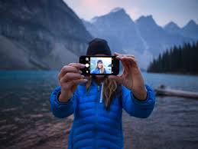
- Where was it taken?

- What where you doing in it?

- Who else was there?

- Write down 3 feelings you have about the picture.

Spend 15 minutes on this task:

Choose a sink in your house and clean it. Using the right cleaning products scrub and wash the sink and taps so it is sparkling clean!

Spend 15 minutes on this task:

Make a list of 10 of the TV programmes/films you have been enjoying in lockdown.

- List them in alphabetical order.

- Next, write down your favourite character beside each one.

Spend 15 minutes on this task:

Help mum or dad write the shopping list for your next visit to the shops:
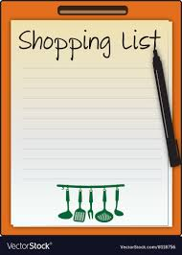
Think about the food, drinks, cleaning products, toiletries and anything else you might need.

